**CSEE 5542 Big Data Analytics and Applications**

**Lab assignment 4 Report**

Pavankumar Manchala

Class Id: 16

Team - 5

**Objectives:**

1. Image Caption Generation by implementing bottom up attention model.

**Introduction:**

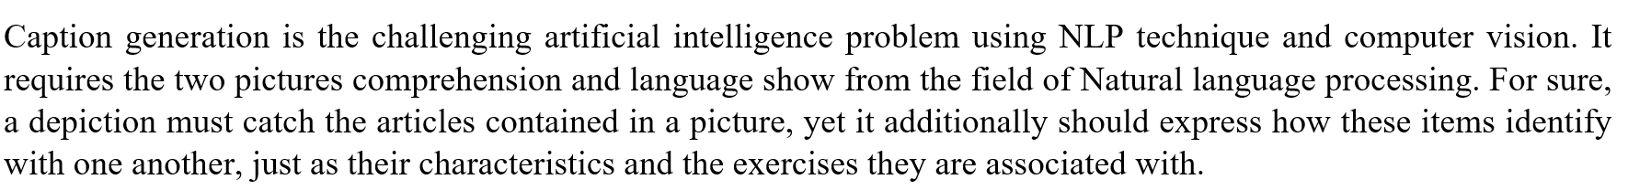

**Platforms used:**

1. Pycharm

**Packages Installed:**

1. Tensorflow r1.0
2. nltk
3. Pandas
4. PIL
5. MSCOCO images and captions.
6. Inception v4

**Results:**

Dataset: We used MSCOCO dataset for training the model.

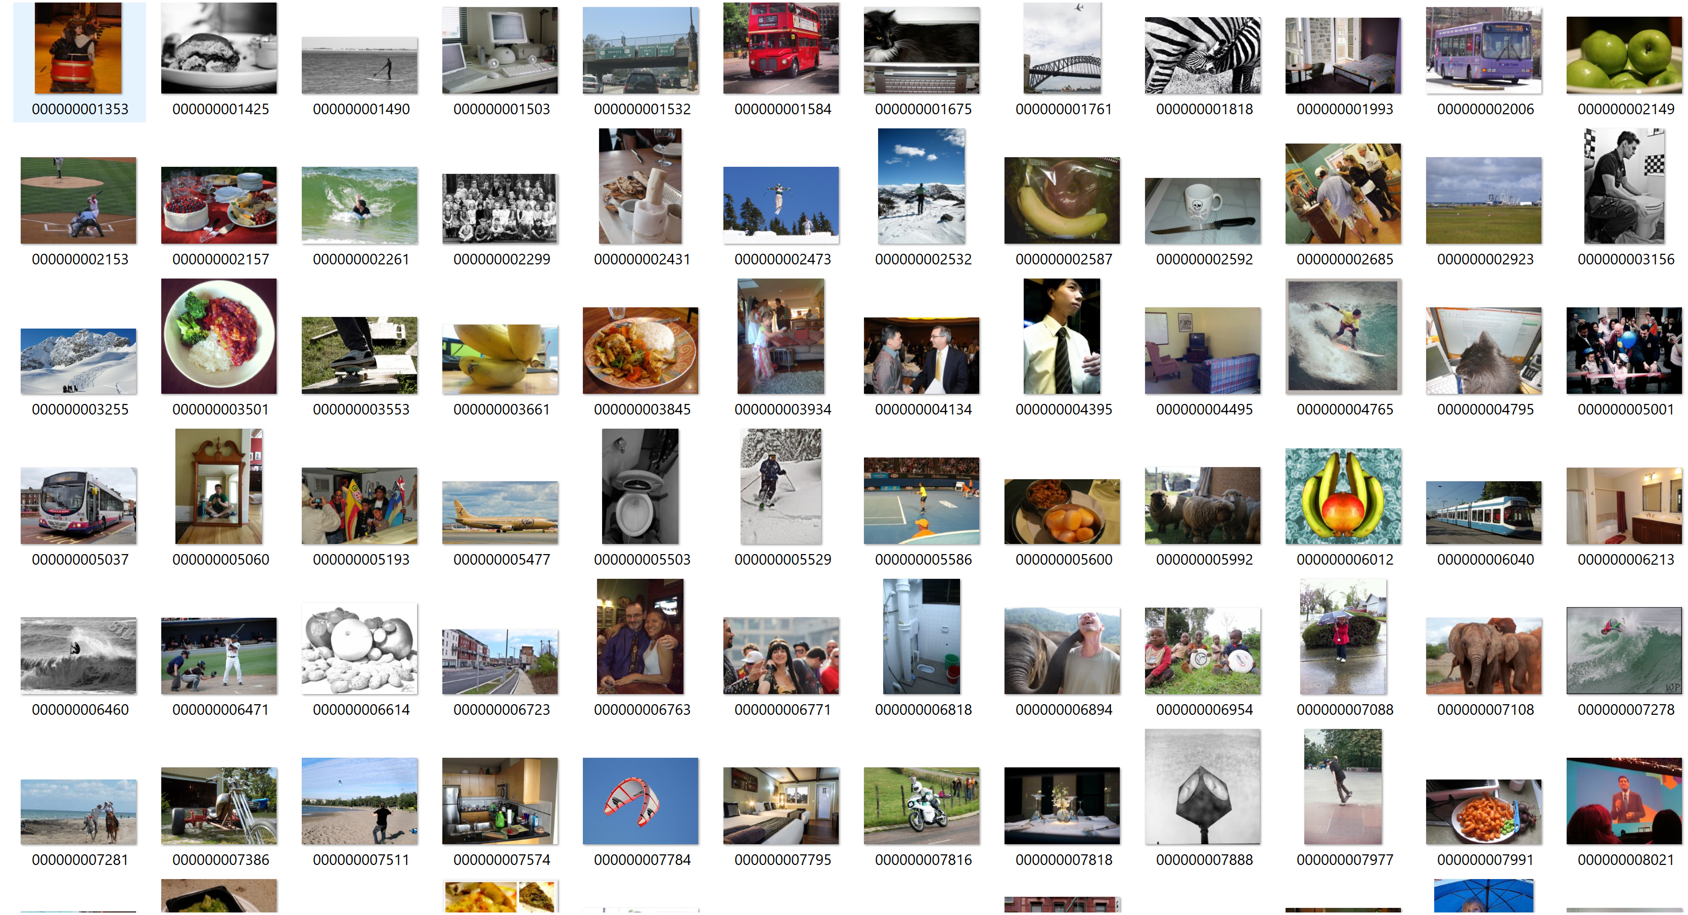

The screenshots of Inception model, which used as recognition model which obtained 78% accuracy on ImageNet dataset:

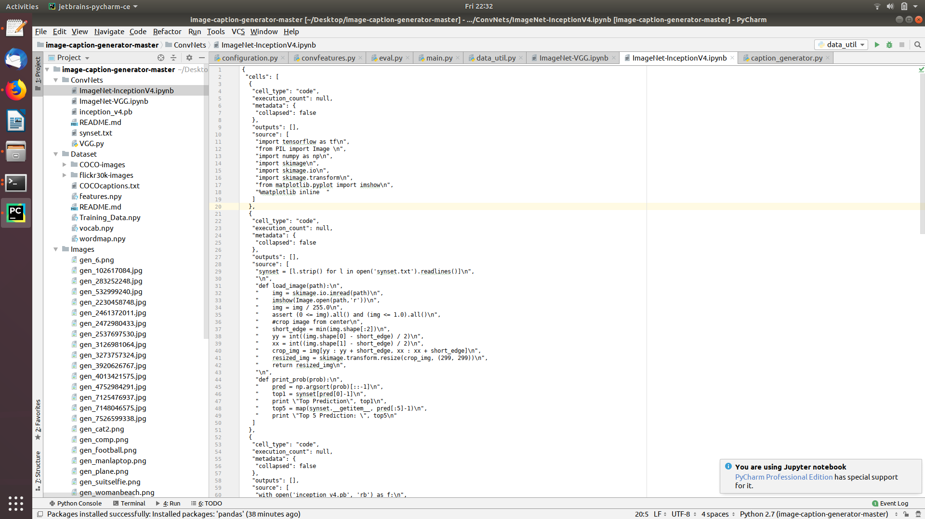

To implement attention model, we used several steps.

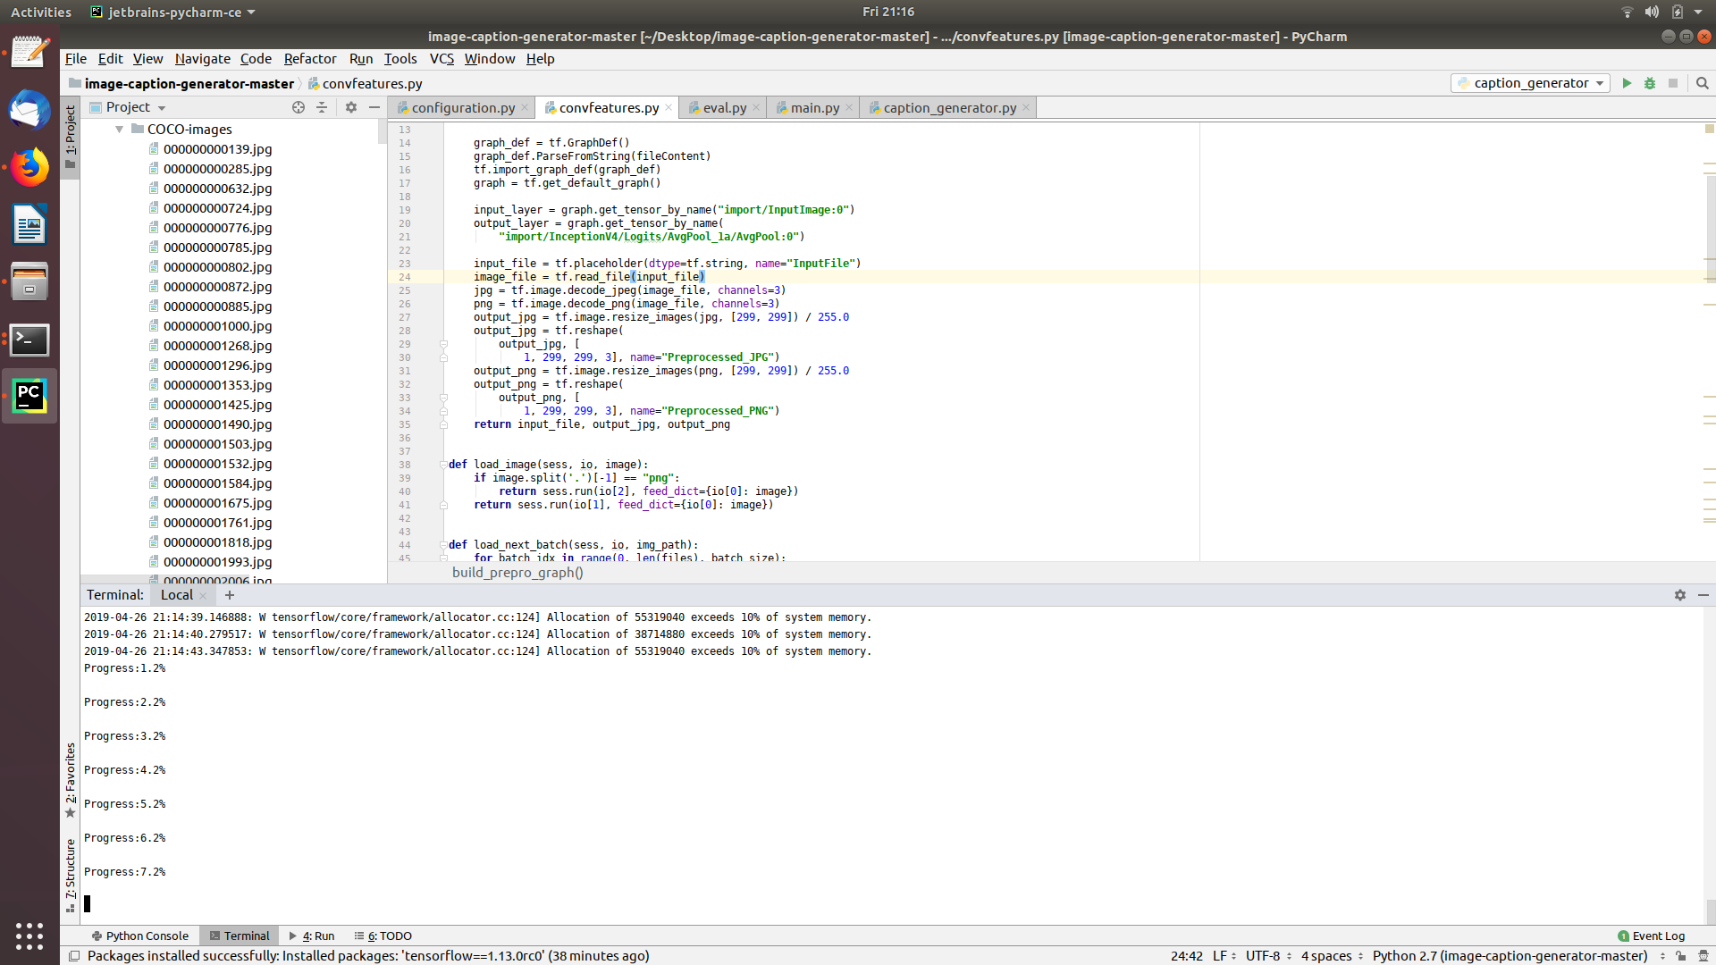

With this we generated a features.npy file which extracted features of the images. This file with images used for training the model and helps to generate the captions.

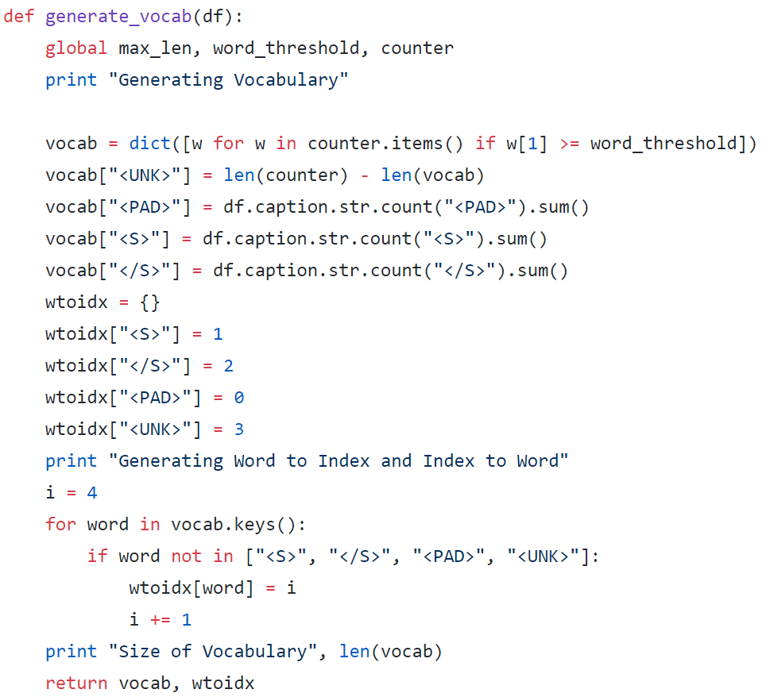

Captions generated:

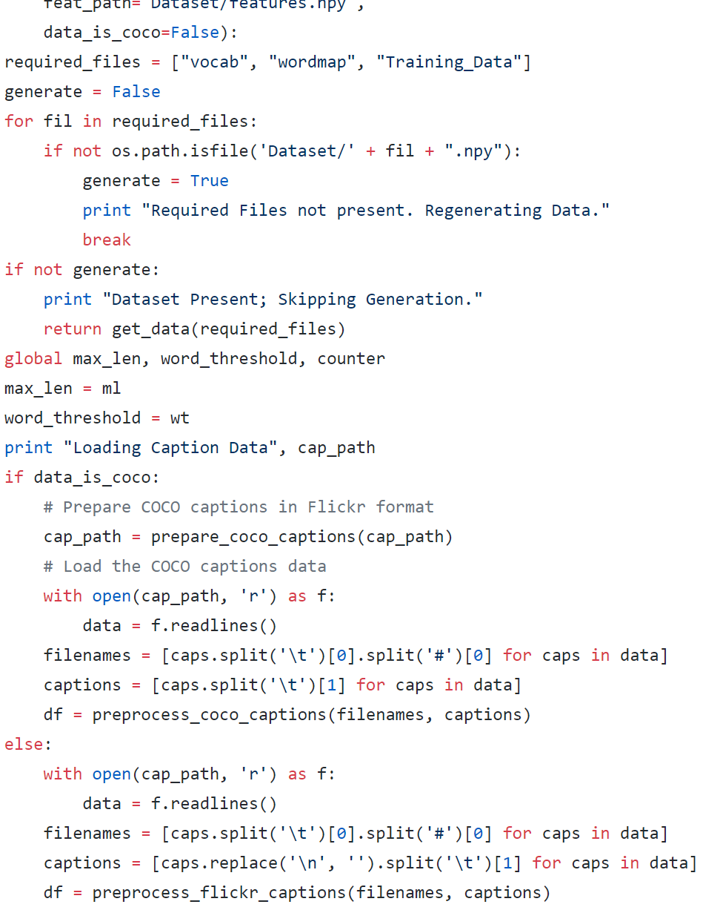

Blue score obtained:

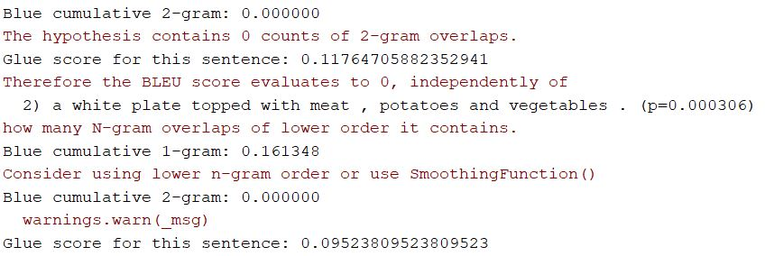

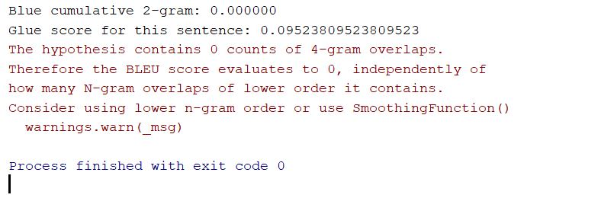

References:

* Show and Tell: A Neural Image caption generator- Oriol Vinyals, Alexander Toshev, Samy Bengio, Dumitru Erhan
* <https://arxiv.org/abs/1707.07998>